PL-300 Exam Practice Questions.docx
https://biconsultingpro-my.sharepoint.com/:w:/p/connect/IQCB-JIwgO6oRJ4zRa0jwjAXAV9ISBNocIuSMMzAP2a-H6A?rtime=6gQBIcHK3kg

- You have a custom connector that returns ID, From, To, Subject, Body, and Has Attachments for every email sent during the past year. More than 10 million records are returned.
You build a report analyzing the internal networks of employees based on whom they send emails to.
You need to prevent report recipients from reading the analyzed emails. The solution must minimize the model size.
What should you do?
- A. Implement row-level security (RLS) so that the report recipients can only see results based on the emails they sent.
- B. Remove the Subject and Body columns during the import.
- C. From Model view, set the Subject and Body columns to Hidden.
Correct Answer: B
Incorrect Answers:
A, C: Does not reduce the size of the model.

You have the tables shown in the following table.
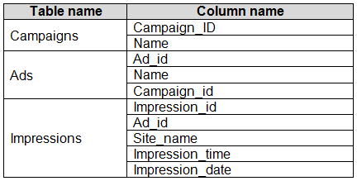
The Impressions table contains approximately 30 million records per month.
You need to create an ad analytics system to meet the following requirements:
✑ Present ad impression counts for the day, campaign, and Site_name. The analytics for the last year are required.
✑ Minimize the data model size.
Which two actions should you perform? Each correct answer presents part of the solution.
NOTE: Each correct selection is worth one point.
- A. Group the impressions by Ad_id, Site_name, and Impression_date. Aggregate by using the CountRows function.
- B. Create one-to-many relationships between the tables.
- C. Create a calculated measure that aggregates by using the COUNTROWS function.
- D. Create a calculated table that contains Ad_id, Site_name, and Impression_date.
Correct Answer: AB

- Your company has training videos that are published to Microsoft Stream.
You need to surface the videos directly in a Microsoft Power BI dashboard.
Which type of tile should you add?
- A. video
- B. custom streaming data
- C. text box
- D. web content
Correct Answer: B
The only way to visualize a streaming dataset is to add a tile and use the streaming dataset as a custom streaming data source.
Reference:
https://docs.microsoft.com/en-us/power-bi/connect-data/service-real-time-streaming

- You open a query in Power Query Editor.
You need to identify the percentage of empty values in each column as quickly as possible.
Which Data Preview option should you select?
- A. Show whitespace
- B. Column profile
- C. Column distribution
- D. Column quality
Correct Answer: D
Column quality: In this section, we can easily see valid, Error and Empty percentage of data values associated with the Selected table.
Note: In Power Query Editor, Under View tab in Data Preview Section we can see the following data profiling functionalities:
✑ Column quality
✑ Column distribution
✑ Column profile
Reference:
https://community.powerbi.com/t5/Community-Blog/Data-Profiling-in-Power-BI-Power-BI-Update-April-2019/ba-p/674555

5.
You have a prospective customer list that contains 1,500 rows of data. The list contains the following fields:
✑ First name
✑ Last name
✑ Email address
✑ State/Region
✑ Phone number
You import the list into Power Query Editor.
You need to ensure that the list contains records for each State/Region to which you want to target a marketing campaign.
Which two actions should you perform? Each correct answer presents part of the solution.
NOTE: Each correct selection is worth one point.
A. Open the Advanced Editor.
B. Select Column quality.
C. Enable Column profiling based on entire dataset.
D. Select Column distribution.
E. Select Column profile.
Correct Answer: DE
Data Profiling, Quality & Distribution in Power BI / Power Query features
To enable these features, you need to go to the View tab ֳ Data Preview Group ֳ Check the following:
✑ Column quality
✑ Column profile
✑ Column distribution
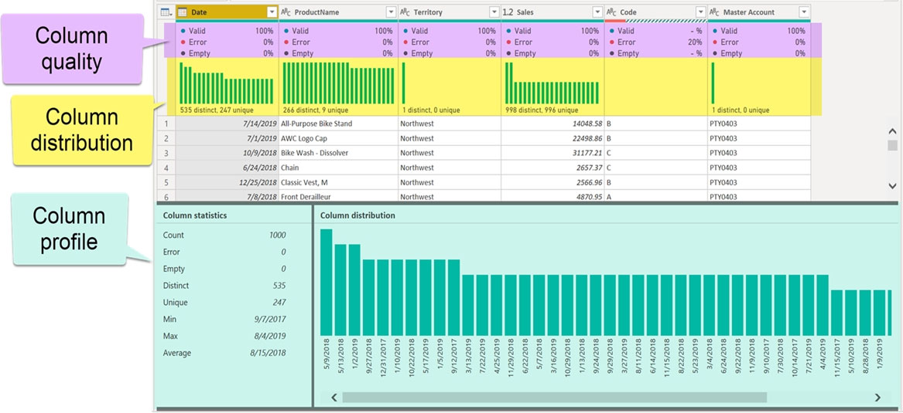

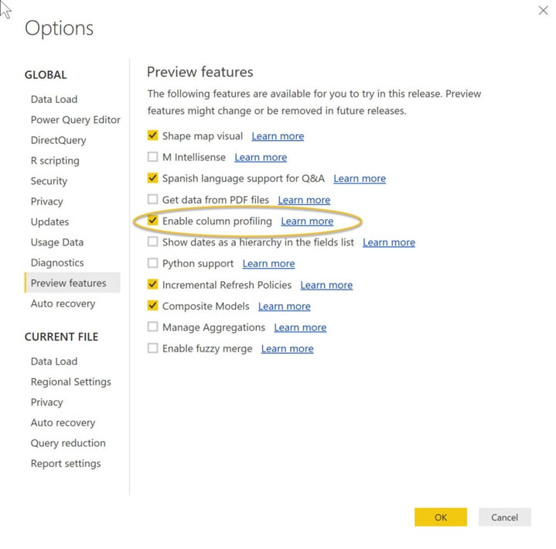

✑ Column distribution
Can use it to visually realize that your query is missing some data because of distinct and uniqueness counts.

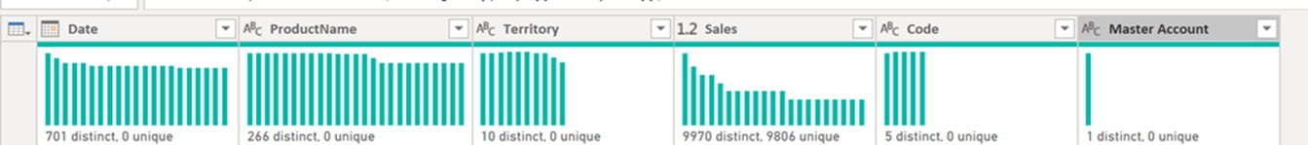

Reference:
https://www.poweredsolutions.co/2019/08/13/data-profiling-quality-distribution-in-power-bi-power-query/ https://www.altentertraining.com/microsoft/power-bi/column-profiling-is-good/

6. HOTSPOT -
You have an API that returns more than 100 columns. The following is a sample of column names.
✑ client_notified_timestamp
✑ client_notified_source
✑ client_notified_sourceid
✑ client_notified_value
✑ client_responded_timestamp
✑ client_responded_source
✑ client_responded_sourceid
✑ client_responded_value
You plan to include only a subset of the returned columns.
You need to remove any columns that have a suffix of sourceid.
How should you complete the Power Query M code? To answer, select the appropriate options in the answer area.
NOTE: Each correct selection is worth one point.
Hot Area:

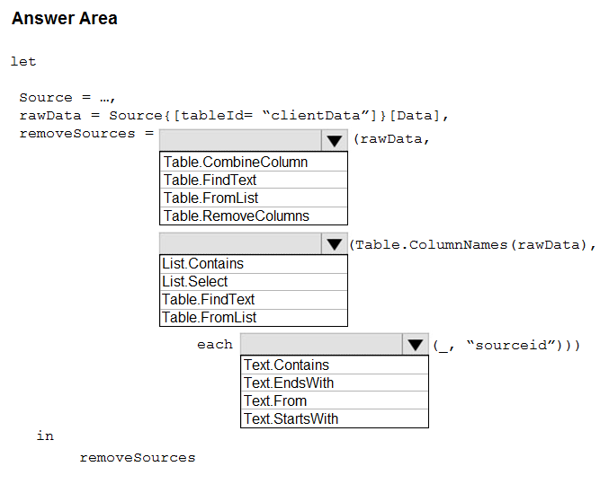

Correct Answer:
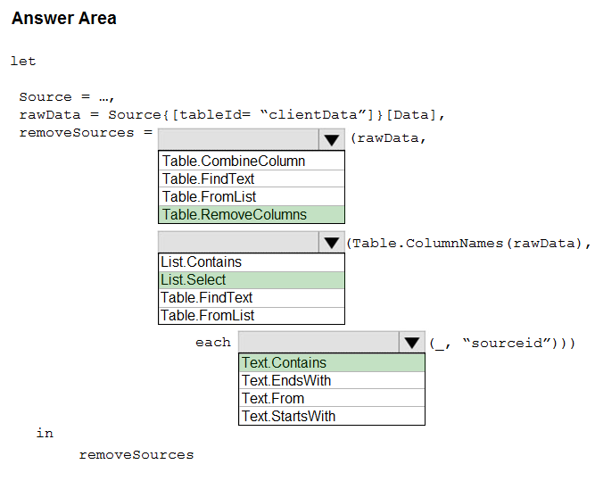

Explanation:

Box 1: Table.RemoveColumns -
When you do ג€Remove Columnsג€ Power Query uses the Table.RemoveColumns function
Box 2: List.Select -
Get a list of columns.
Box 3: Text.Contains -
Example code to remove columns with a slash (/):
let
Source = Excel.Workbook(File.Contents("C: Source"), null, true),
#"1_Sheet" = Source{[Item="1",Kind="Sheet"]}[Data],
#"Promoted Headers" = Table.PromoteHeaders(#"1_Sheet", [PromoteAllScalars=true]),
// get columns which contains any slash among values
ColumnsToRemove =
List.Select(
// get a list of all columns
Table.ColumnNames(#"Promoted Headers"),
(columnName) =>
let
// get all values of a columns
ColumnValues = Table.Column(#"Promoted Headers", columnName),
// go through values and stop when you find the first occurence of a text containing a slash
// if there is a value with a slash, return true else false
ContainsSlash = List.AnyTrue(List.Transform(ColumnValues, each Text.Contains(_, "/"))) in
ContainsSlash -
),
// remove columns
Result = Table.RemoveColumns(#"Promoted Headers", ColumnsToRemove) in
Result -
Reference:
https://community.powerbi.com/t5/Power-Query/Remove-columns-containing-a-certain-value/td-p/759657

7.
DRAG DROP -
You are building a dataset from a JSON file that contains an array of documents.
You need to import attributes as columns from all the documents in the JSON file. The solution must ensure that date attributes can be used as date hierarchies in
Microsoft Power BI reports.
Which three actions should you perform in sequence? To answer, move the appropriate actions from the list of actions to the answer area and arrange them in the correct order.
Select and Place:

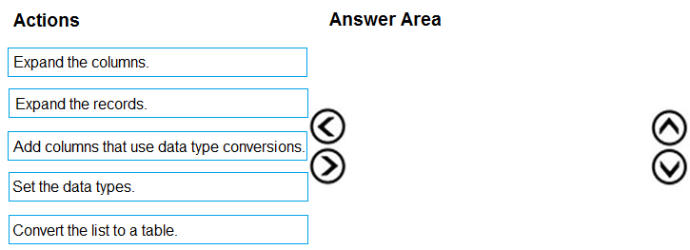
Correct Answer:

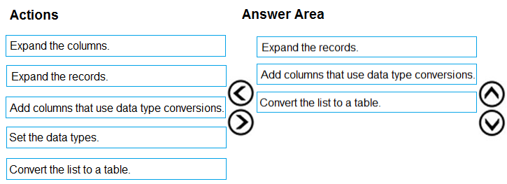

Explanation:
Step 1: Expand the records.
First Open Power BI desktop and navigate to Power Query, import the JSON file, then load the data, click on the record to expand it and to see the record and list.
Step 2: Add columns that use data type conversions.
Step 3: Convert the list to a table

8.
You import two Microsoft Excel tables named Customer and Address into Power Query. Customer contains the following columns:
✑ Customer ID
✑ Customer Name
✑ Phone
✑ Email Address
✑ Address ID
Address contains the following columns:
✑ Address ID
✑ Address Line 1
✑ Address Line 2
✑ City
✑ State/Region
✑ Country
✑ Postal Code
The Customer ID and Address ID columns represent unique rows.
You need to create a query that has one row per customer. Each row must contain City, State/Region, and Country for each customer.
What should you do?
- A. Merge the Customer and Address tables.
- B. Transpose the Customer and Address tables.
- C. Group the Customer and Address tables by the Address ID column.
- D. Append the Customer and Address tables.

Correct Answer: A
There are two primary ways of combining queries: merging and appending.
✑ When you have one or more columns that youג€™d like to add to another query, you merge the queries.
✑ When you have additional rows of data that youג€™d like to add to an existing query, you append the query.
Reference:
https://docs.microsoft.com/en-us/power-bi/connect-data/desktop-shape-and-combine-data

9. You have the following three versions of an Azure SQL database:
✑ Test
✑ Production
✑ Development
You have a dataset that uses the development database as a data source.
You need to configure the dataset so that you can easily change the data source between the development, test, and production database servers from powerbi.com.
Which should you do?
- A. Create a JSON file that contains the database server names. Import the JSON file to the dataset.
- B. Create a parameter and update the queries to use the parameter.
- C. Create a query for each database server and hide the development tables.
- D. Set the data source privacy level to Organizational and use the ReplaceValue Power Query M function.
Correct Answer: B
As you can't edit datasets data sources in Power BI service, we recommend using parameters to store connection details such as instance names and database names, instead of using a static connection string. This allows you to manage the connections through the Power BI service web portal, or using APIs, at a later stage.
Reference:
https://docs.microsoft.com/en-us/power-bi/create-reports/deployment-pipelines-best-practices
10. You have a CSV file that contains user complaints. The file contains a column named Logged. Logged contains the date and time each complaint occurred. The data in Logged is in the following format: 2018-12-31 at 08:59.
You need to be able to analyze the complaints by the logged date and use a built-in date hierarchy.
What should you do?
- A. Change the data type of the Logged column to Date.
- B. Apply a transformation to extract the last 11 characters of the Logged column and set the data type of the new column to Date.
- C. Create a column by example that starts with 2018-12-31 and set the data type of the new column to Date.
- D. Add a conditional column that outputs 2018 if the Logged column starts with 2018 and set the data type of the new column to Whole Number.
Correct Answer: C
To use a built-in-date hierarchy, you need to set the data type of the new column to Date.
Reference:
https://docs.microsoft.com/en-us/power-bi/create-reports/desktop-add-column-from-example https://www.exceljetconsult.com.ng/home/blog/power-query-split-date-and-time-into-separate-columns/

11. You have an Azure SQL database that contains sales transactions. The database is updated frequently.
You need to generate reports from the data to detect fraudulent transactions. The data must be visible within five minutes of an update.
How should you configure the data connection?
- A. Add a SQL statement.
- B. Set Data Connectivity mode to DirectQuery.
- C. Set the Command timeout in minutes setting.
- D. Set Data Connectivity mode to Import.
Correct Answer: B
With Power BI Desktop, when you connect to your data source, it's always possible to import a copy of the data into the Power BI Desktop. For some data sources, an alternative approach is available: connect directly to the data source using DirectQuery.
DirectQuery: No data is imported or copied into Power BI Desktop. For relational sources, the selected tables and columns appear in the Fields list. For multi- dimensional sources like SAP Business Warehouse, the dimensions and measures of the selected cube appear in the Fields list. As you create or interact with a visualization, Power BI Desktop queries the underlying data source, so youג€™re always viewing current data.
Incorrect Answers:
D: Import: The selected tables and columns are imported into Power BI Desktop. As you create or interact with a visualization, Power BI Desktop uses the imported data. To see underlying data changes since the initial import or the most recent refresh, you must refresh the data, which imports the full dataset again.
Reference:
https://docs.microsoft.com/en-us/power-bi/connect-data/desktop-use-directquery

12.
You have a data model that contains many complex DAX expressions. The expressions contain frequent references to the RELATED and RELATEDTABLE functions.
You need to recommend a solution to minimize the use of the RELATED and RELATEDTABLE functions.
What should you recommend?
- A. Split the model into multiple models.
- B. Hide unused columns in the model.
- C. Merge tables by using Power Query.
- D. Transpose.
Correct Answer: C
Combining data means connecting to two or more data sources, shaping them as needed, then consolidating them into a useful query.
When you have one or more columns that youג€™d like to add to another query, you merge the queries.
Note: The RELATEDTABLE function is a shortcut for CALCULATETABLE function with no logical expression.
CALCULATETABLE evaluates a table expression in a modified filter context and returns A table of values.
Reference:
https://docs.microsoft.com/en-us/power-bi/connect-data/desktop-shape-and-combine-data

13. You have a large dataset that contains more than 1 million rows. The table has a datetime column named Date.
You need to reduce the size of the data model without losing access to any data.
What should you do?
- A. Round the hour of the Date column to startOfHour.
- B. Change the data type of the Date column to Text.
- C. Trim the Date column.
- D. Split the Date column into two columns, one that contains only the time and another that contains only the date.

Correct Answer: D
We have to separate date & time tables. Also, we donג€™t need to put the time into the date table, because the time is repeated every day.
Split your DateTime column into a separate date & time columns in fact table, so that you can join the date to the date table & the time to the time table. The time need to be converted to the nearest round minute or second so that every time in your data corresponds to a row in your time table.
Reference:
https://intellipaat.com/community/6461/how-to-include-time-in-date-hierarchy-in-power-bi https://apexinsights.net/blog/top-5-tips-to-optimise-data-model

14. DRAG DROP -
You are modeling data in a table named SalesDetail by using Microsoft Power BI.
You need to provide end users with access to the summary statistics about the SalesDetail data. The users require insights on the completeness of the data and the value distributions.
Which three actions should you perform in sequence? To answer, move the appropriate actions from the list of actions to the answer area and arrange them in the correct order,
Select and Place:

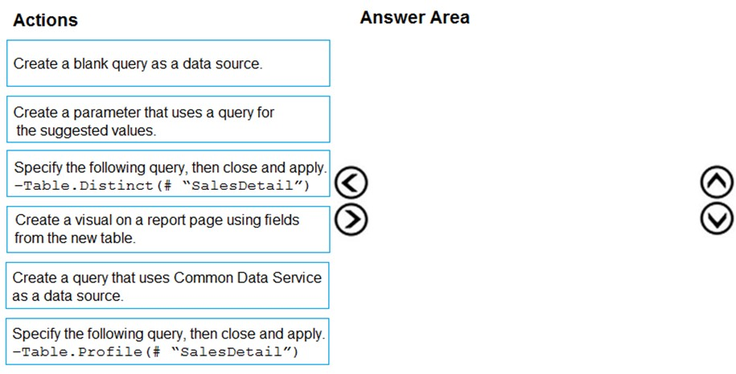

Correct Answer:

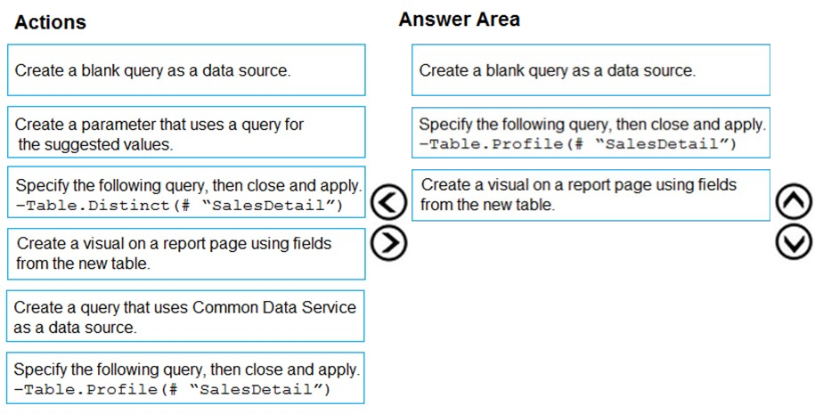

Explanation:

Step 1: Create a blank query as a data source
Start with a New Source in Power Query Editor, and then Blank Query.

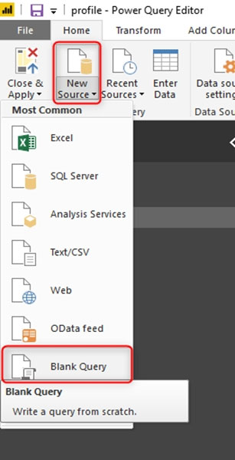

Create a parameter that use a query for suggested values.
Step 2: Specify the following query, then close and apply. -Table.Profile(#ֲ¨SalesDetail")
In the new blank query, in the formula bar (if you don’t see the formula bar, check the formula bar option in the View tab of the Power Query Editor), type below expression:
=Table.Profile()
Note that this code is not complete yet, we need to provide a table as the input of this function.
Note: The Table.Profile() function takes a value of type table and returns a table that displays, for each column in the original table, the minimum, maximum, average, standard deviation, count of values, count of null values and count of distinct values.
Step 3: Create a visual for the query table.
The profiling data that you get from Table.Profile function is like below;

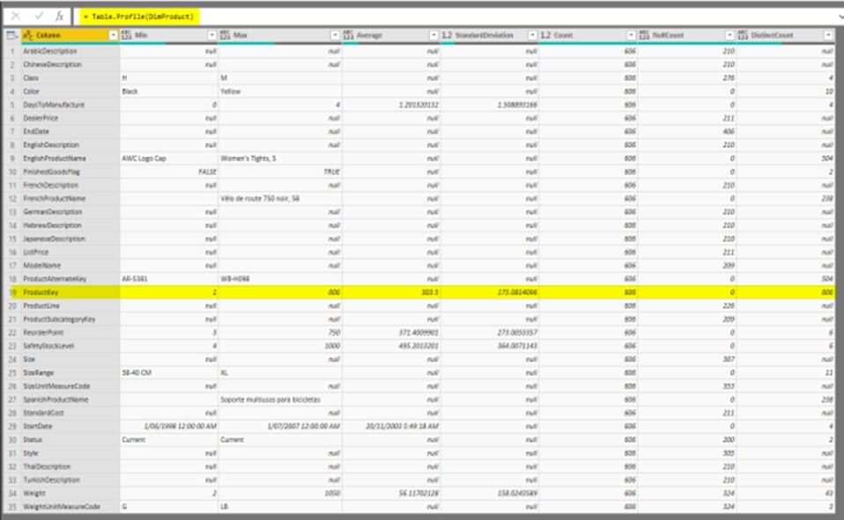

After loading the data into Power BI, you will have the table with all columns, and it can be used in any visuals.
Reference:
https://radacad.com/create-a-profiling-report-in-power-bi-give-the-end-user-information-about-the-data

15. You create the following step by using Power Query Editor.
- Table.ReplaceValue(SalesLT_Address,"1318","1319",Replacer.ReplaceText,{"AddressLine1"})
A row has a value of 21318 Lasalle Street in the AddressLine1 column.
What will the value be when the step is applied?
- A. 1318
- B. 1319
- C. 21318 Lasalle Street
- D. 21319 Lasalle Street

Correct Answer: D
Example:
Replace the text "ur" with the text "or" in the table.
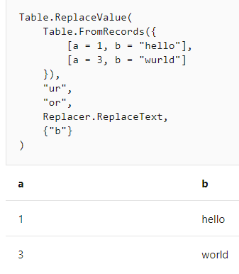
Reference:
https://docs.microsoft.com/en-us/powerquery-m/table-replacevalue

In case you want to practice online, you can use the following link:
Need More questions Answers to Practice?
Please send us an email at connect@biconsultingpro.com
Cost: USD 30
Pass your exam guaranteed.


